**Task 2: Use a Password Manager**

• **OBJECTIVE**

Task: Set up and use a password manager.

Details: Install a password manager like LastPass or Bitwarden.

Store and manage passwords securely.

Use the password manager to generate and fill in strong passwords.

• **STEPS**

1. **Search and Access LastPass**:

* Open your browser and search for "LastPass" on Google.

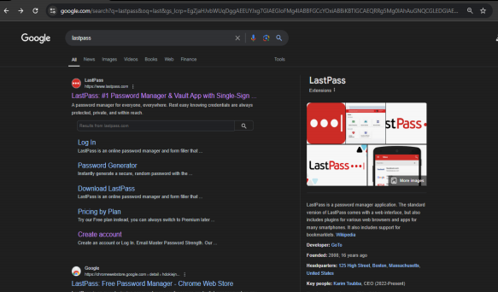

* Navigate to the official LastPass website: https://www.lastpass.com/

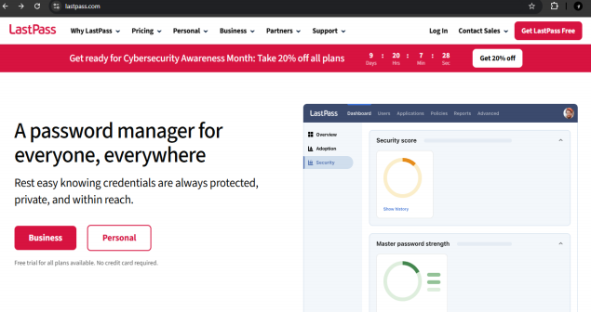

2. **Create an Account in LastPass**:

* On the LastPass homepage, click **Get Started** or **Sign Up**.
* Follow the prompts to create a new account using your email address and a secure master password. The master password will be used to access your stored credentials.

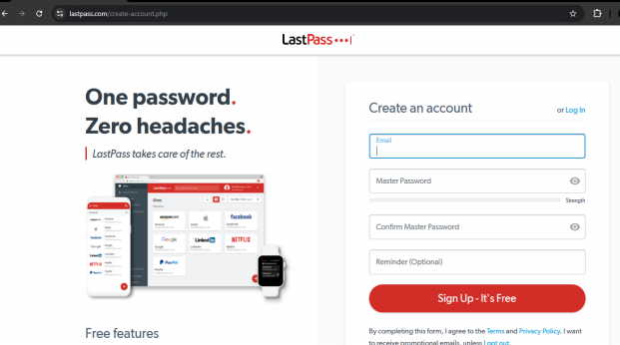

3. **Install the LastPass Extension**:

* After signing up, you will be prompted to install the LastPass browser extension.
* Click **Install Extension** to add it to your browser (in this case, Google Chrome).
* Confirm the installation, and the LastPass icon should appear next to your address bar.

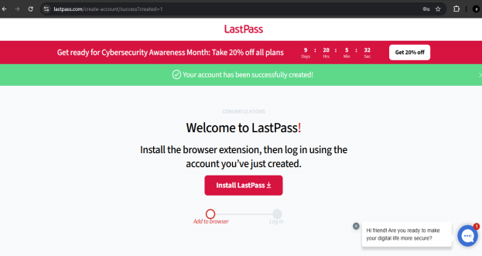

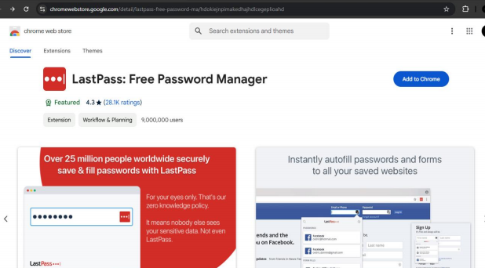

04. **Open LastPass**:

* Click on the LastPass icon in your browser’s toolbar.
* Log in using your email and the master password you created during sign-up.

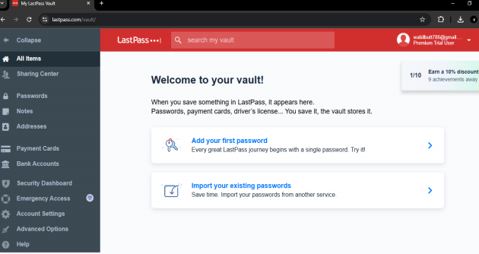

5. **Save a Password**:

* To save a password, go to any website where you have a login (e.g., Gmail, Facebook).
* After entering your login credentials, LastPass will prompt you to save the username and password. Click **Save** to store these securely in your vault.
* You can also manually add passwords by clicking the LastPass icon and navigating to **Vault** > **Add Item**.

